**DSCI6001 – Final Project**

**Applications of Linear Algebra to Chemistry**

In this project we discuss two applications of linear algebra to chemistry:

* To balance chemical equations.
* To calculate the right mix of volumes of chemical substances to produce a chemical solution.

**Balance of Chemical Equations**

We start by describing step by step how to balance an example of a chemical equation.

In this application, we will always have a parametrized solution as we will have more independent variables than equations, been the system homogeneous.

It’s worth noting that mathematically, chemical equations, like:

A + B → AB

mathematically needs to be rewritten/thought as:

A + B = AB

In order to set the proper set of linear equations.

After that, we introduce the case of the combustion of saturated hydrocarbons, creating a general solution to balance any saturated hydrocarbon.

We have developed a Python function that will balance the above scenario. This function relies on a helper one that validates the user entry, which I have tried to use regex (using the python re library): since I was not getting satisfactory results, I abandoned it, although I would have preferred the use of regex as it is very flexible and scalable.

In the case we obtain a fraction of a molecule of O2, we function will return an integer. This normally happens when the number of C atoms in the hydrocarbon is even.

Below is a screenshot of code snippet of how we would use regex in Python. One of the methods of the library re is search. The method returns None if no match is found.

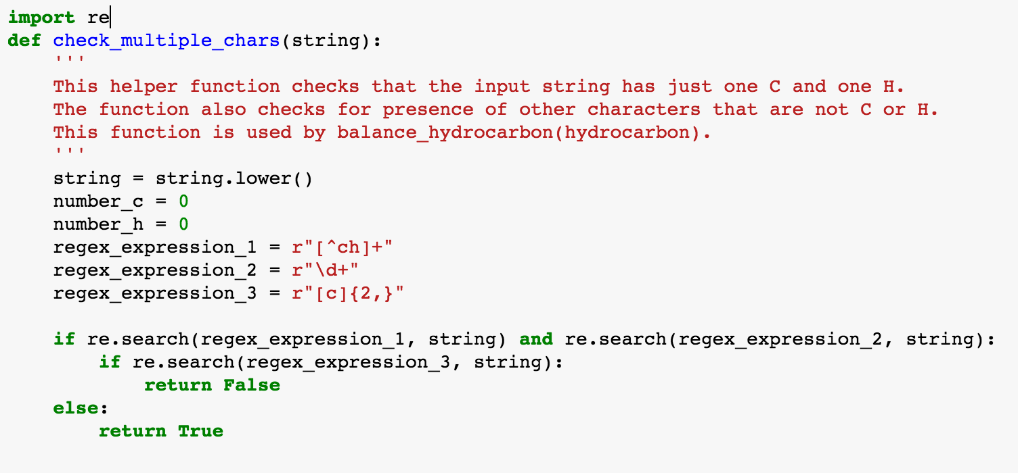

**Mixing of Chemical Substances to Create a Chemical Solution**

This type of application requires a full rank linear system in order to work.

For example, if we have three chemical compounds to be mixed, we will require a system of three linear equations in order to find the proper mix of volumes of chemical compounds.

As described above for chemical equations, mixing chemical substances like:

A + B + C → D

mathematically needs to be rewritten/thought as:

A + B + C = D

We show an example of how to solve a system like the one described above.

Following that, we develop a general solution to find the right mix of volumes for two components in order to produce a chemical solution. We describe all the conditions that need to be met in order for the linear system to be able to produce such solution.

The above has been implemented as a Python function.

Another function, the main one, is also introduced with the goal of helping find the proper volumes of two chemical substances to be mixed.

Following that, we try to find a general solution for a system of three chemical substances to be mixed (represented as a 3x3 matrix) using its minors.

We also create another set of Python functions for this new scenario:

* One that finds the minors of the matrix that represents the three chemicals to be mixed using recursion.
* Another helper function that checks the constraints on the minors.
* The main function that uses the above helper functions and returns a solution, if it exists.

I think I have over engineered the constraints in this scenario, and the corresponding helper function is not working properly.

I’m finding challenging to define adequately the constraints for a 3x3 system, and then translate them into Python code.

**References:**

* http://www.slideshare.net/rasen58/linear-algebra-application-to-chemistry
* http://ndu2009algebra.blogspot.com/2011/04/as-we-struggle-to-increase-number-of.html
* https://regexone.com/references/python